Gilgit:

Attabad Lake

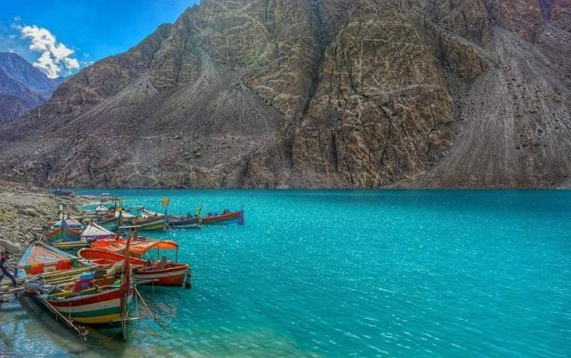

**Attabad Lake** is a lake in Gojal Valley, Hunza, Gilgit Baltistan, an administrative region of Pakistan. The lake was created in January 2010 as a result of the Attabad Disaster. Attabad Lake has become one of the biggest tourist attractions in Gilgit-Baltistan offering activities like boating, jet skiing, fishing and other recreational activities. The lake was formed due to a massive landslide at Attabad Village in Hunza Valley in Gilgit-Baltistan, 14 kilometres (9 mi) upstream (east) of Karimabad that occurred on 4 January 2010. The landslide killed twenty people and blocked the flow of the Hunza River for five months. The lake flooding has displaced 6,000 people from upstream villages, stranded (from land transportation routes) a further 25,000, and inundated over 19 kilometres (12 mi) of the Karakoram Highway .The lake reached 21 kilometres (13 mi) long and over 100 metres (330 ft) in depth by the first week of June 2010 when it began flowing over the landslide dam, completely submerging lower Shishkat and partly flooding Gulmit.